**UberEats Clone LAB 2 Report**

**Himaja Chandaluri | SJSU ID - 015247323**

**YouTube Link:** [**https://youtu.be/6aAp8wqR6hY**](https://youtu.be/6aAp8wqR6hY)

**Goal**: The goal of this project is to build new features on top of the already developed prototype of UberEats application. This prototype is developed using React, Node, Redux, Kafka and MongoDB.

**Purpose:** The purpose of the project is to get hands-on experience on the latest technologies such as React, Node, and Redux. Learn how to establish connections to database. Learn how a client and server architecture is built. How to pass data to client browsers through middleware and populate the data on a single page application.

**System Design:**

**Client Side:** I have designed the web application’s user interface using React and React Bootstrap for styling and customization. Npm package axios is used to make calls to the backend. Additionally, supporting library, Redux is used in order to maintain a global store.

**Server** **Side**: I have used NodeJS, ExpressJS to handle incoming requests from the client end. The server will communicate with the database through kafka message queues. Used MongoDB as the database.

**Database:** I am using MongoDB database.

Additionally, used bcrypt to encrypt sensitive information like passwords. Used Passport-JWT for authentication and authorization. Application deployed on EC2 instance.

**UI Screenshots:**

New features added were pagination in the customer’s orders page. Accepting note while placing order.

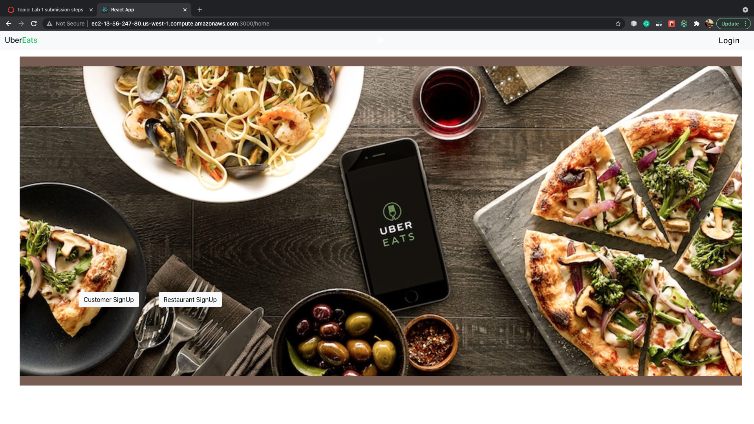

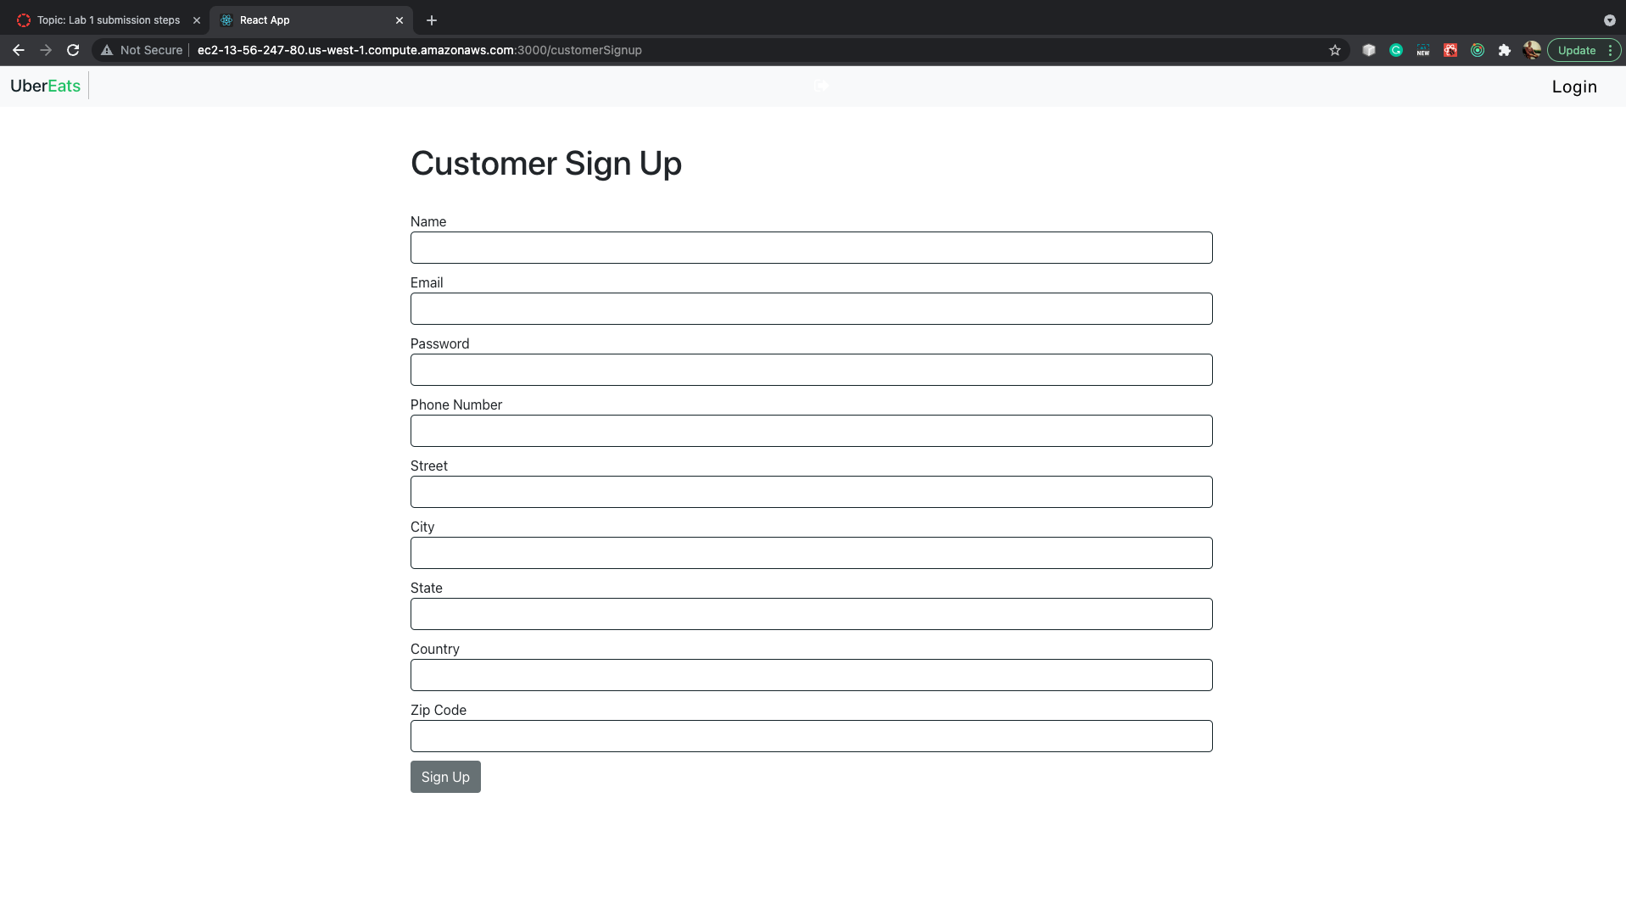

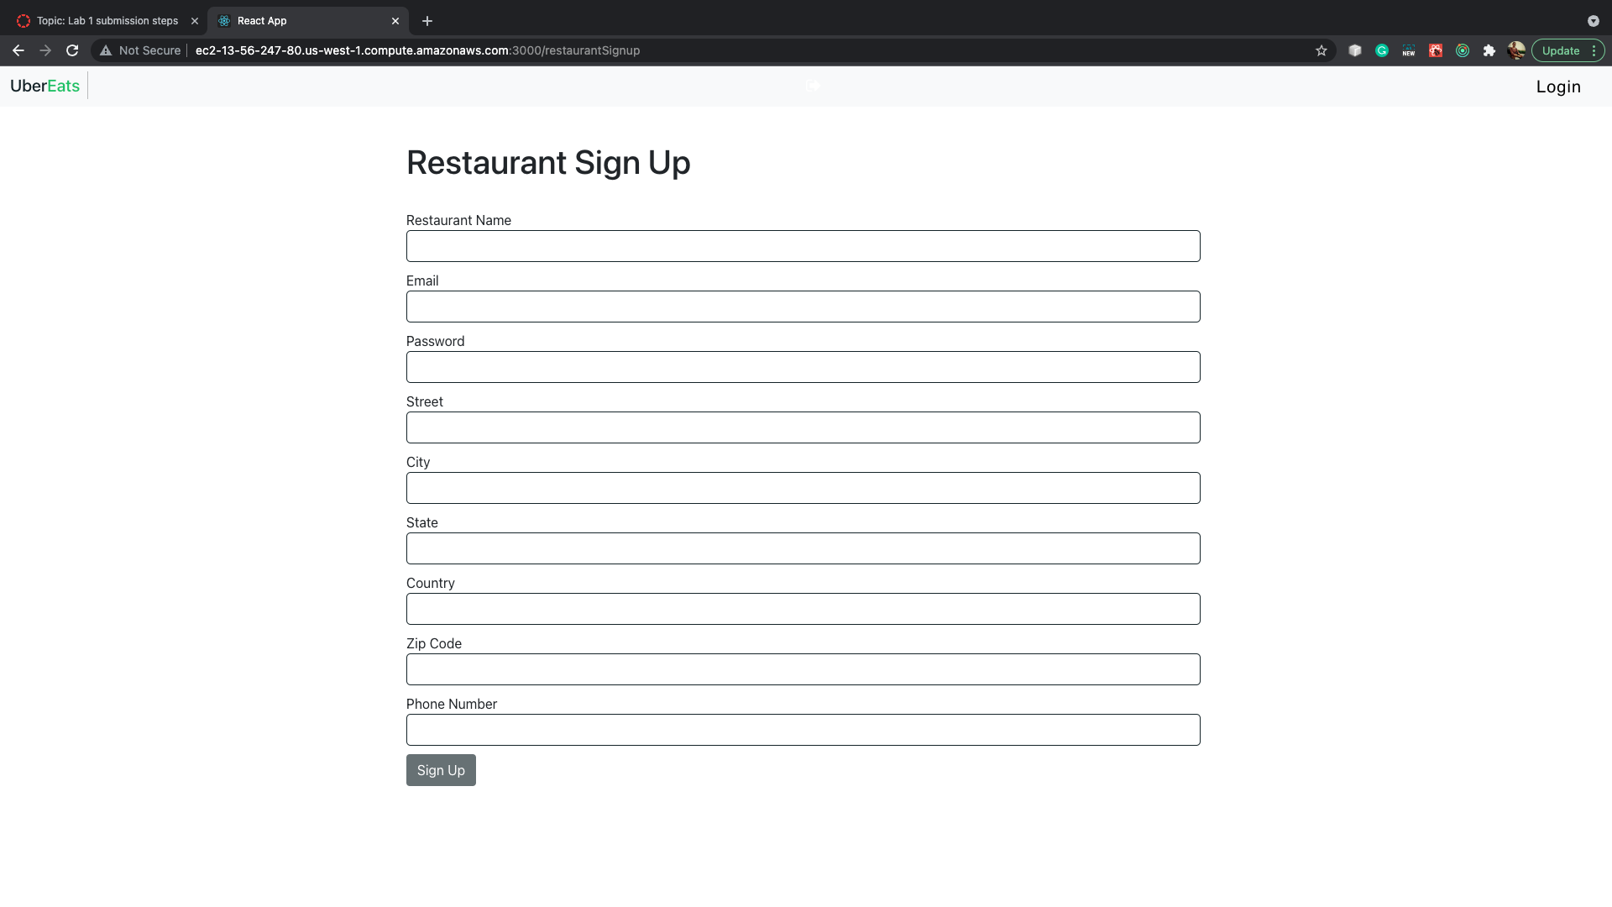

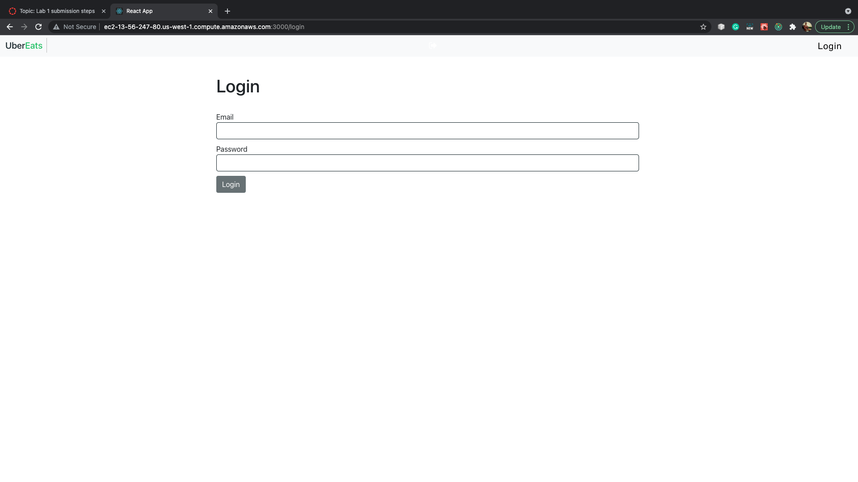

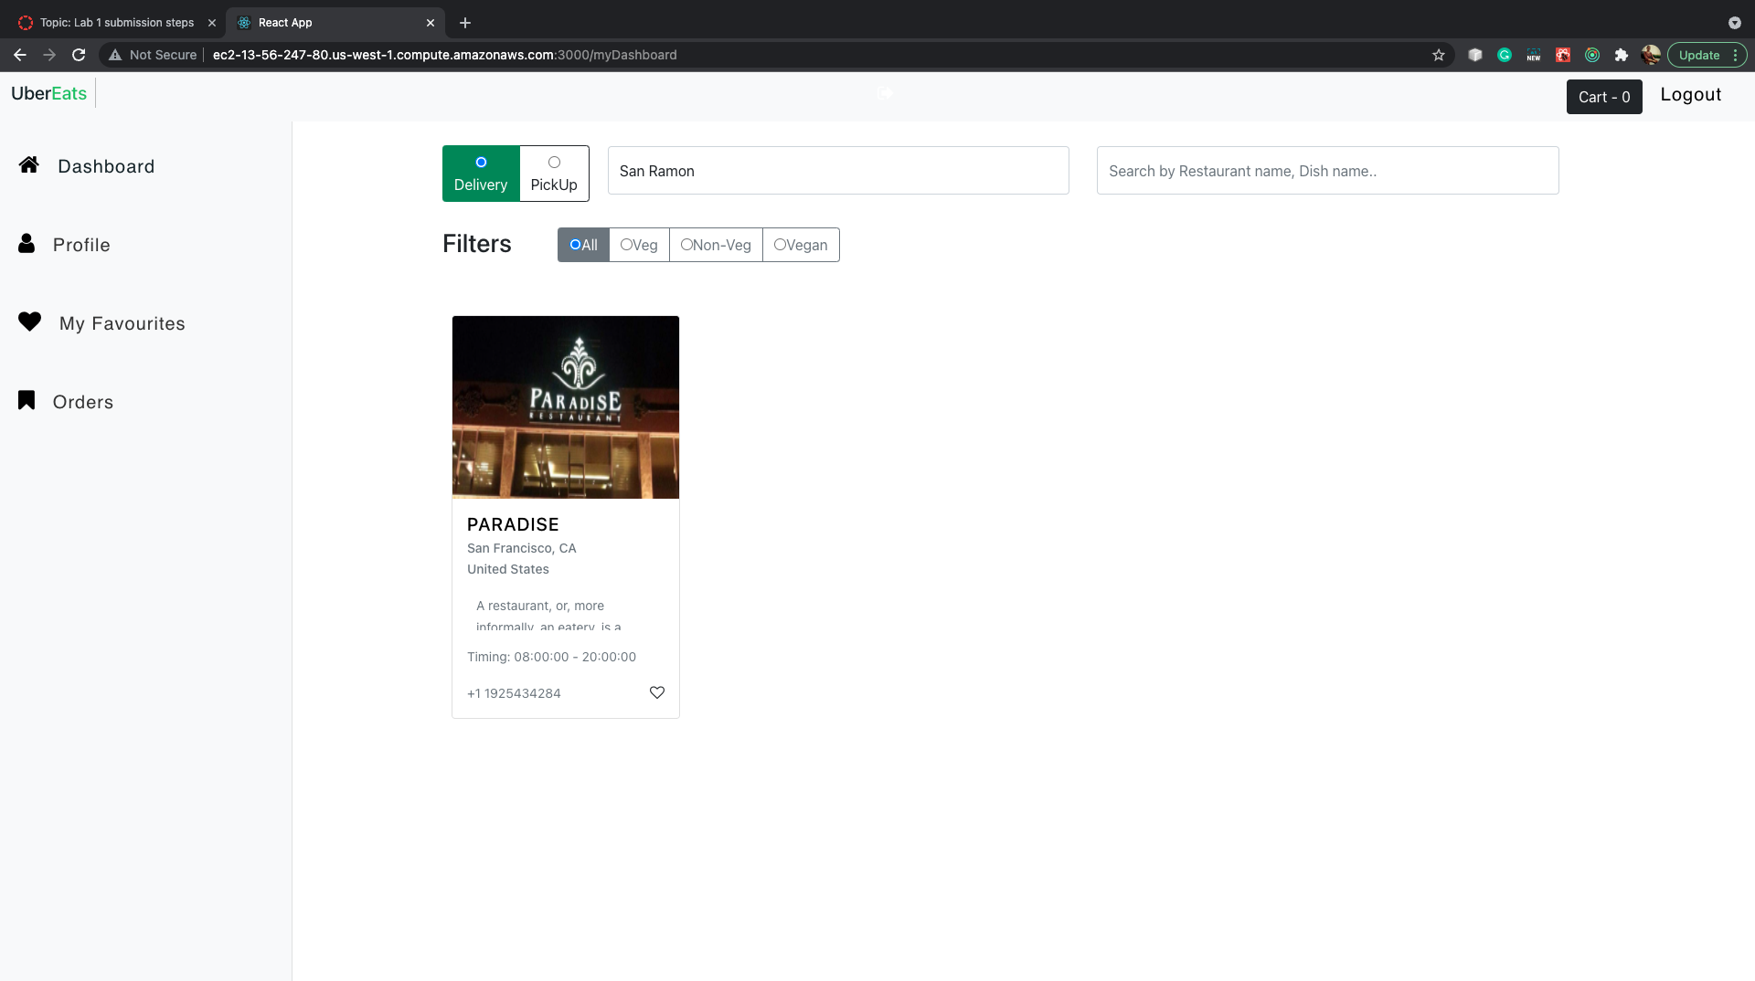

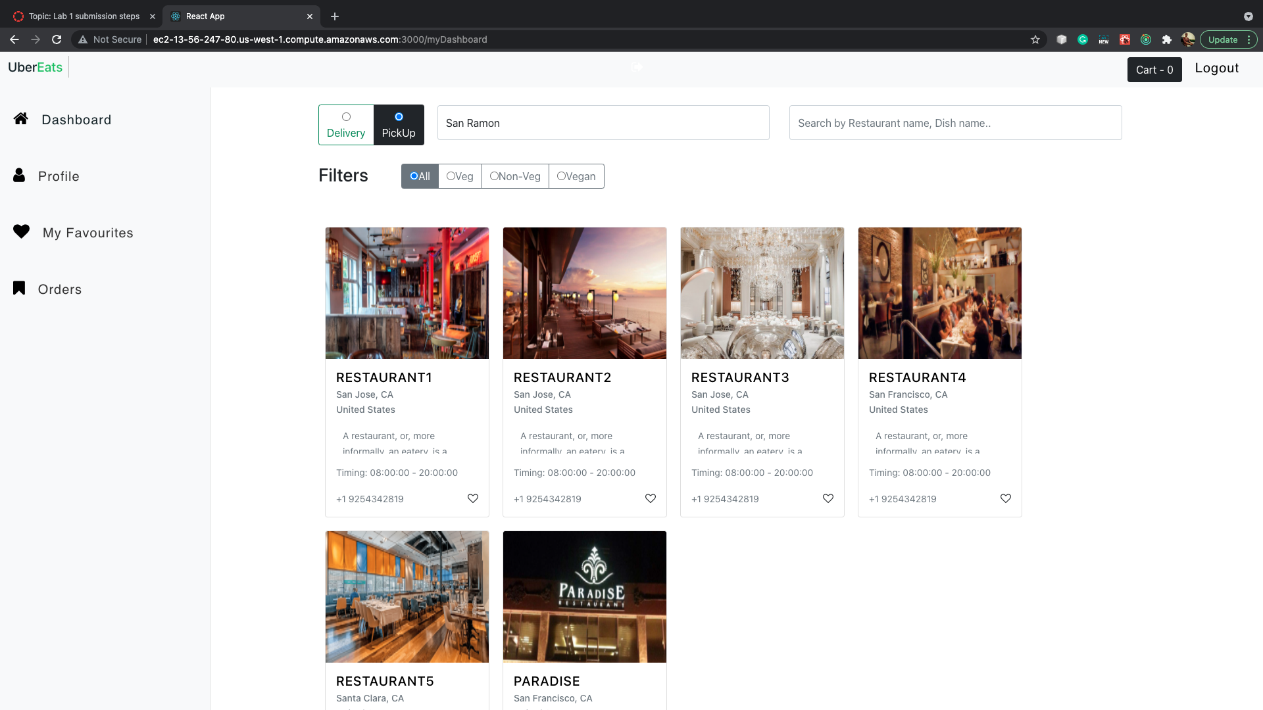

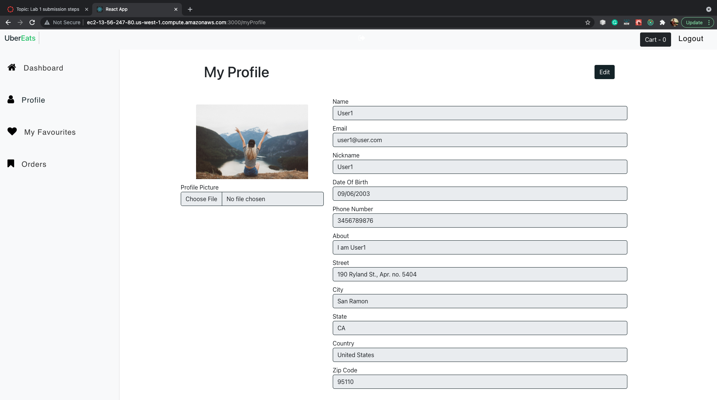

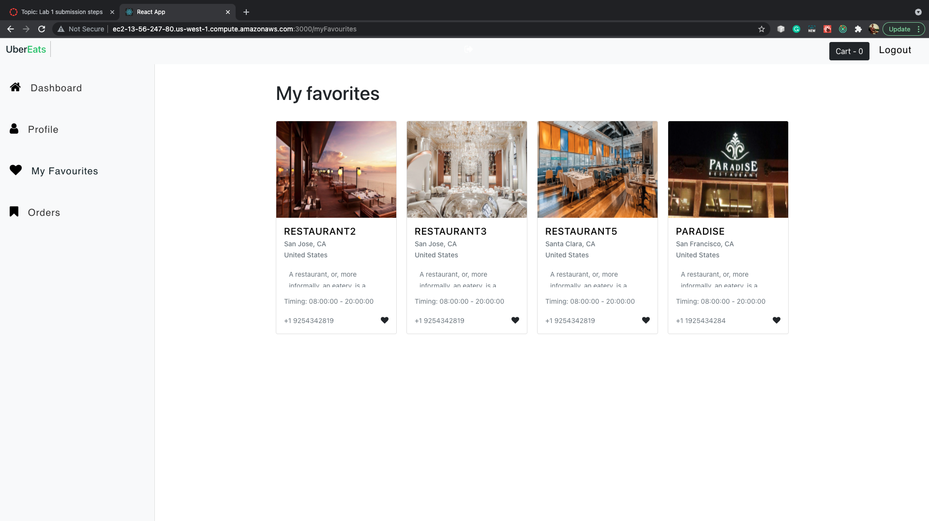

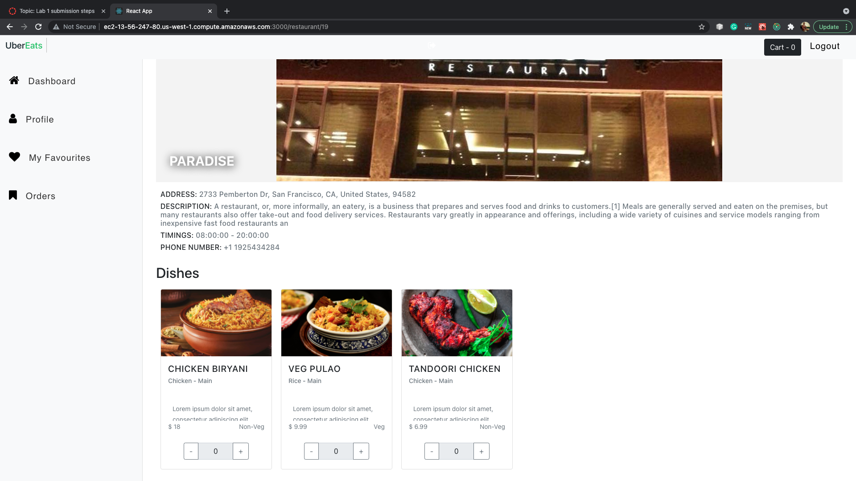

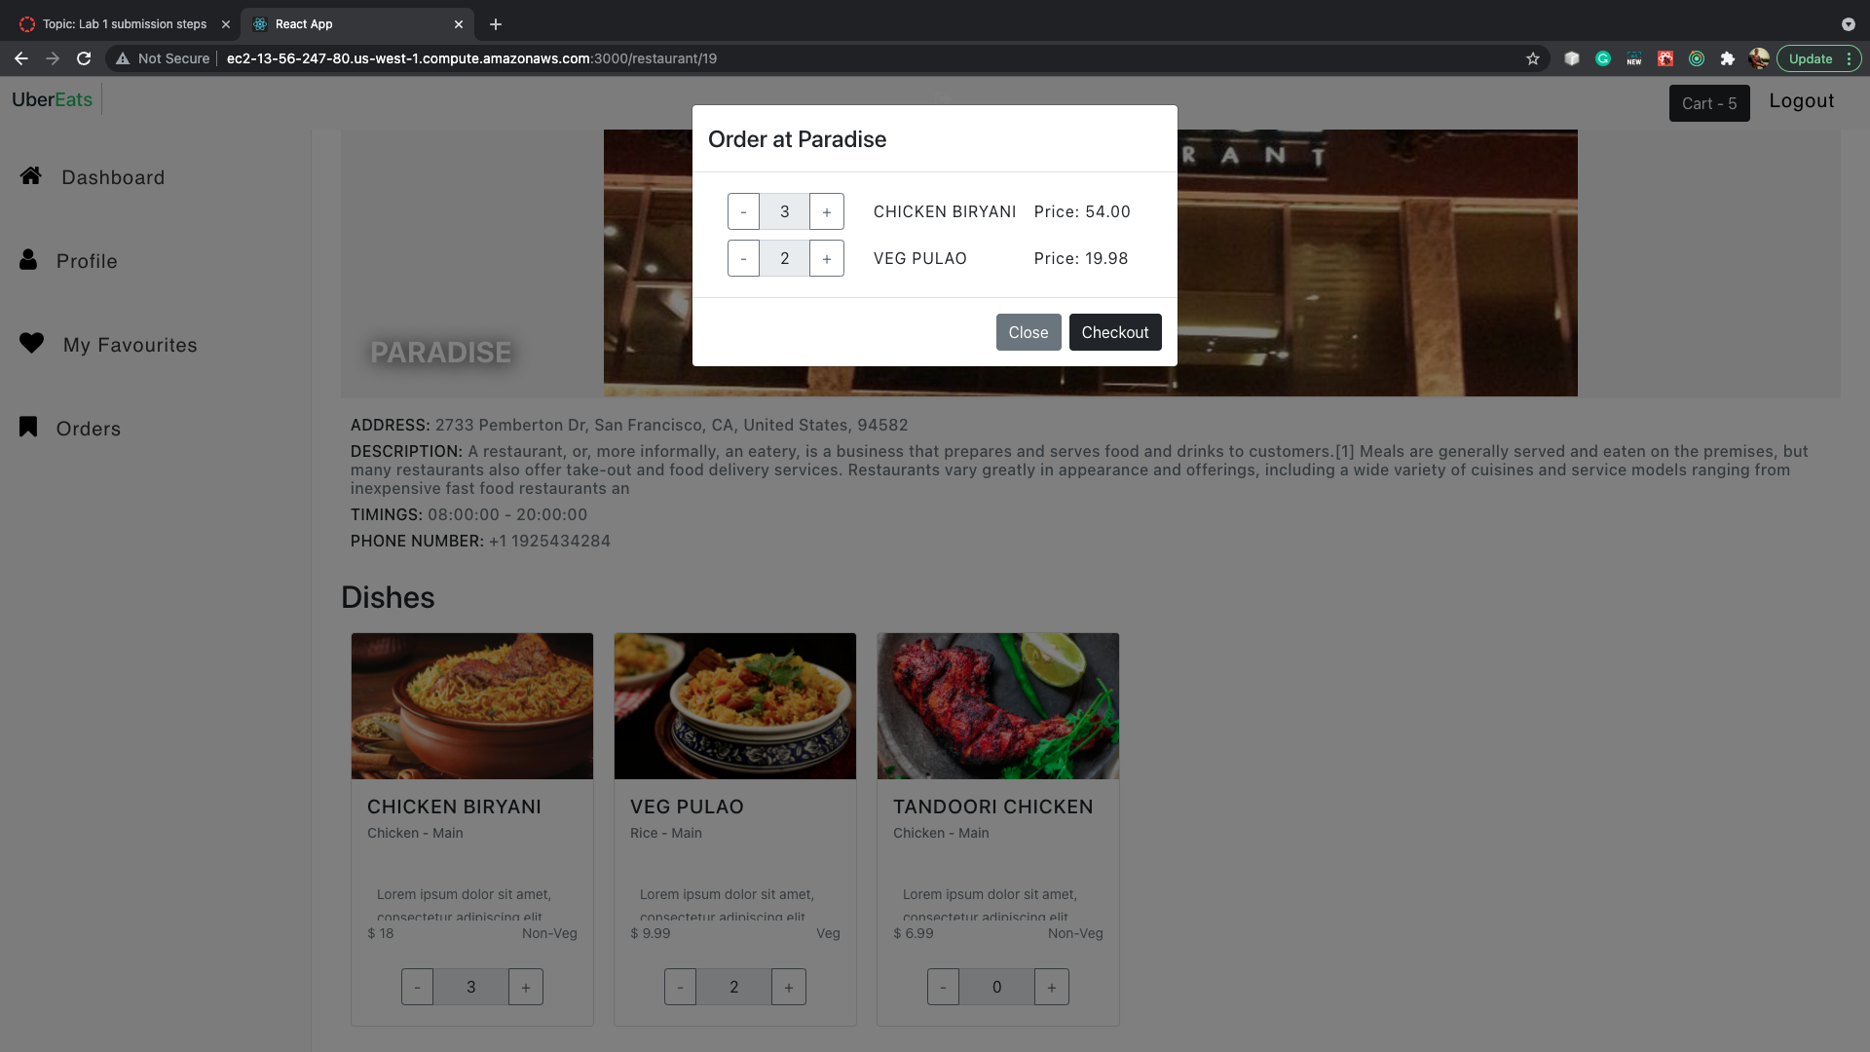

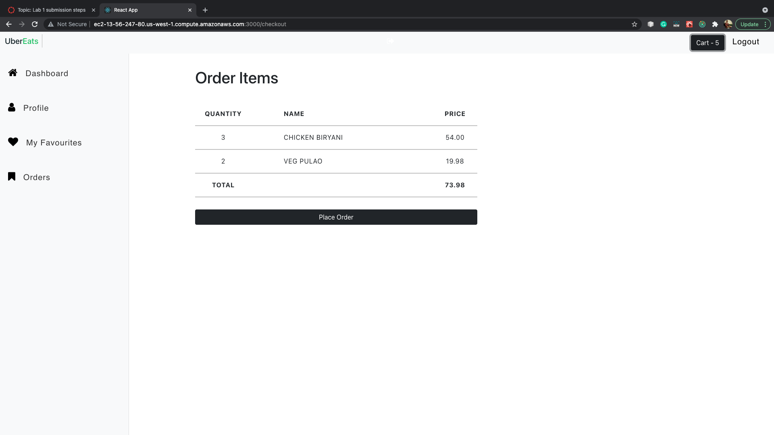

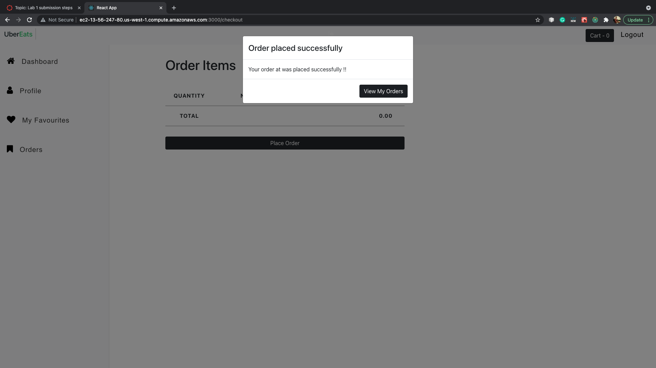

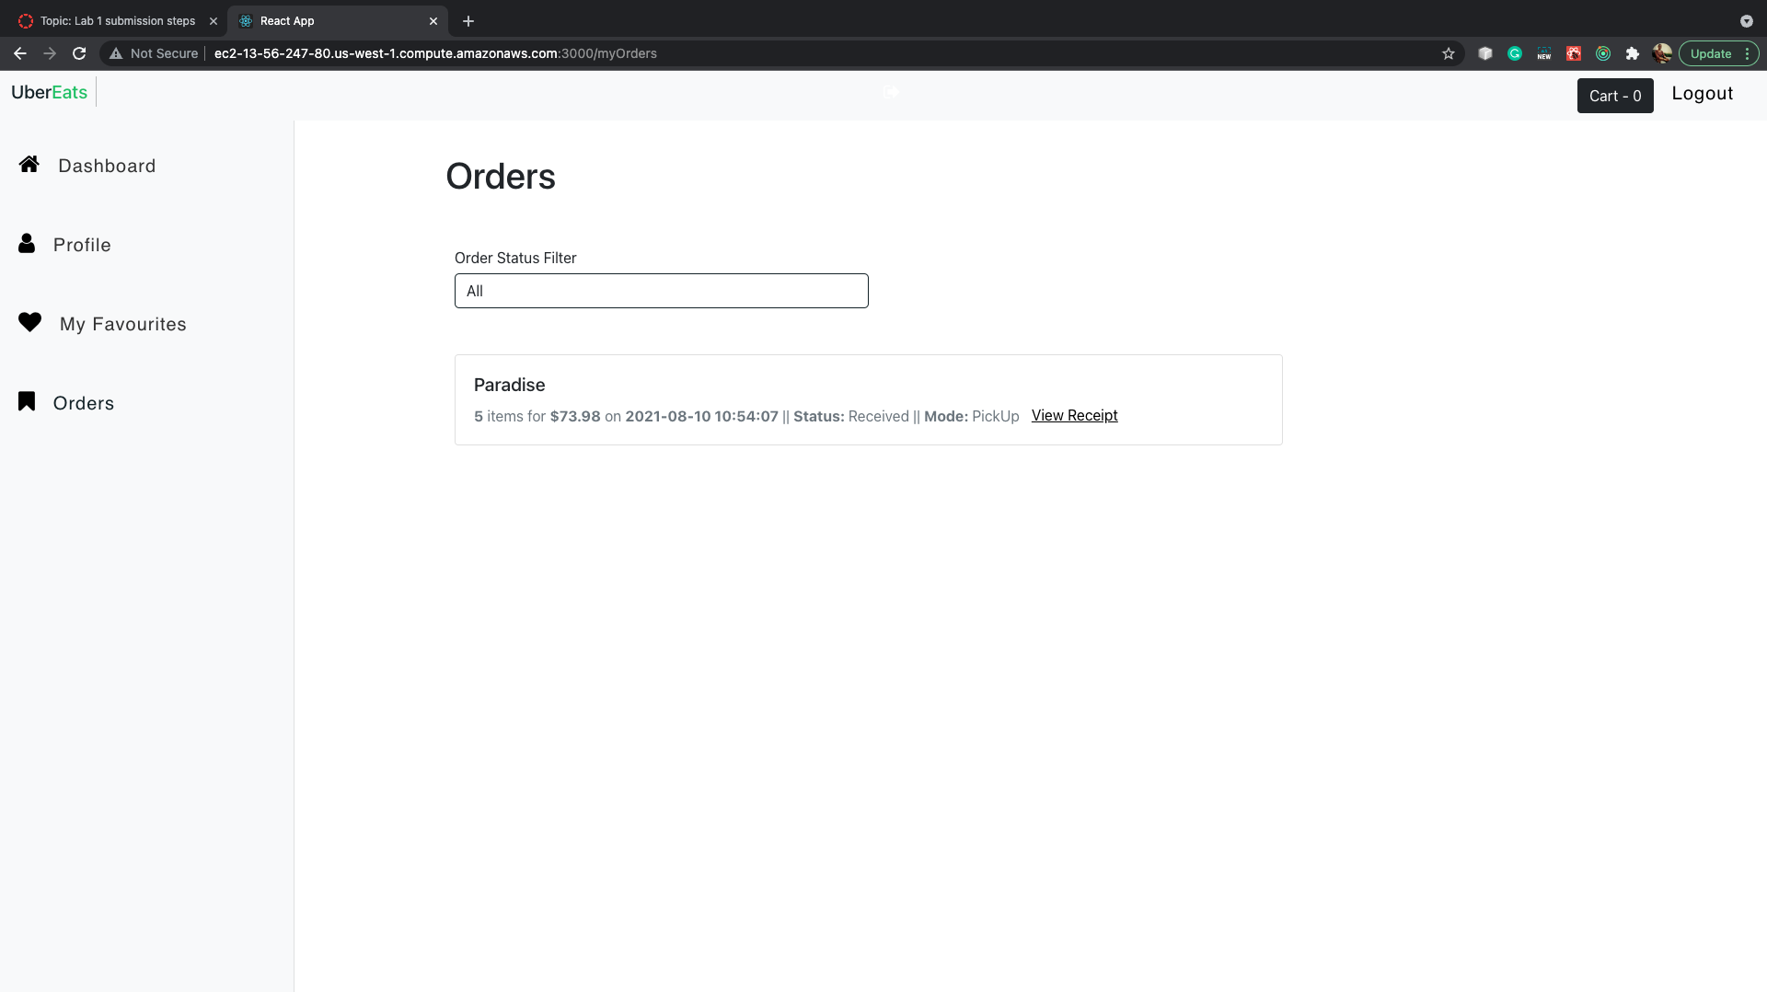

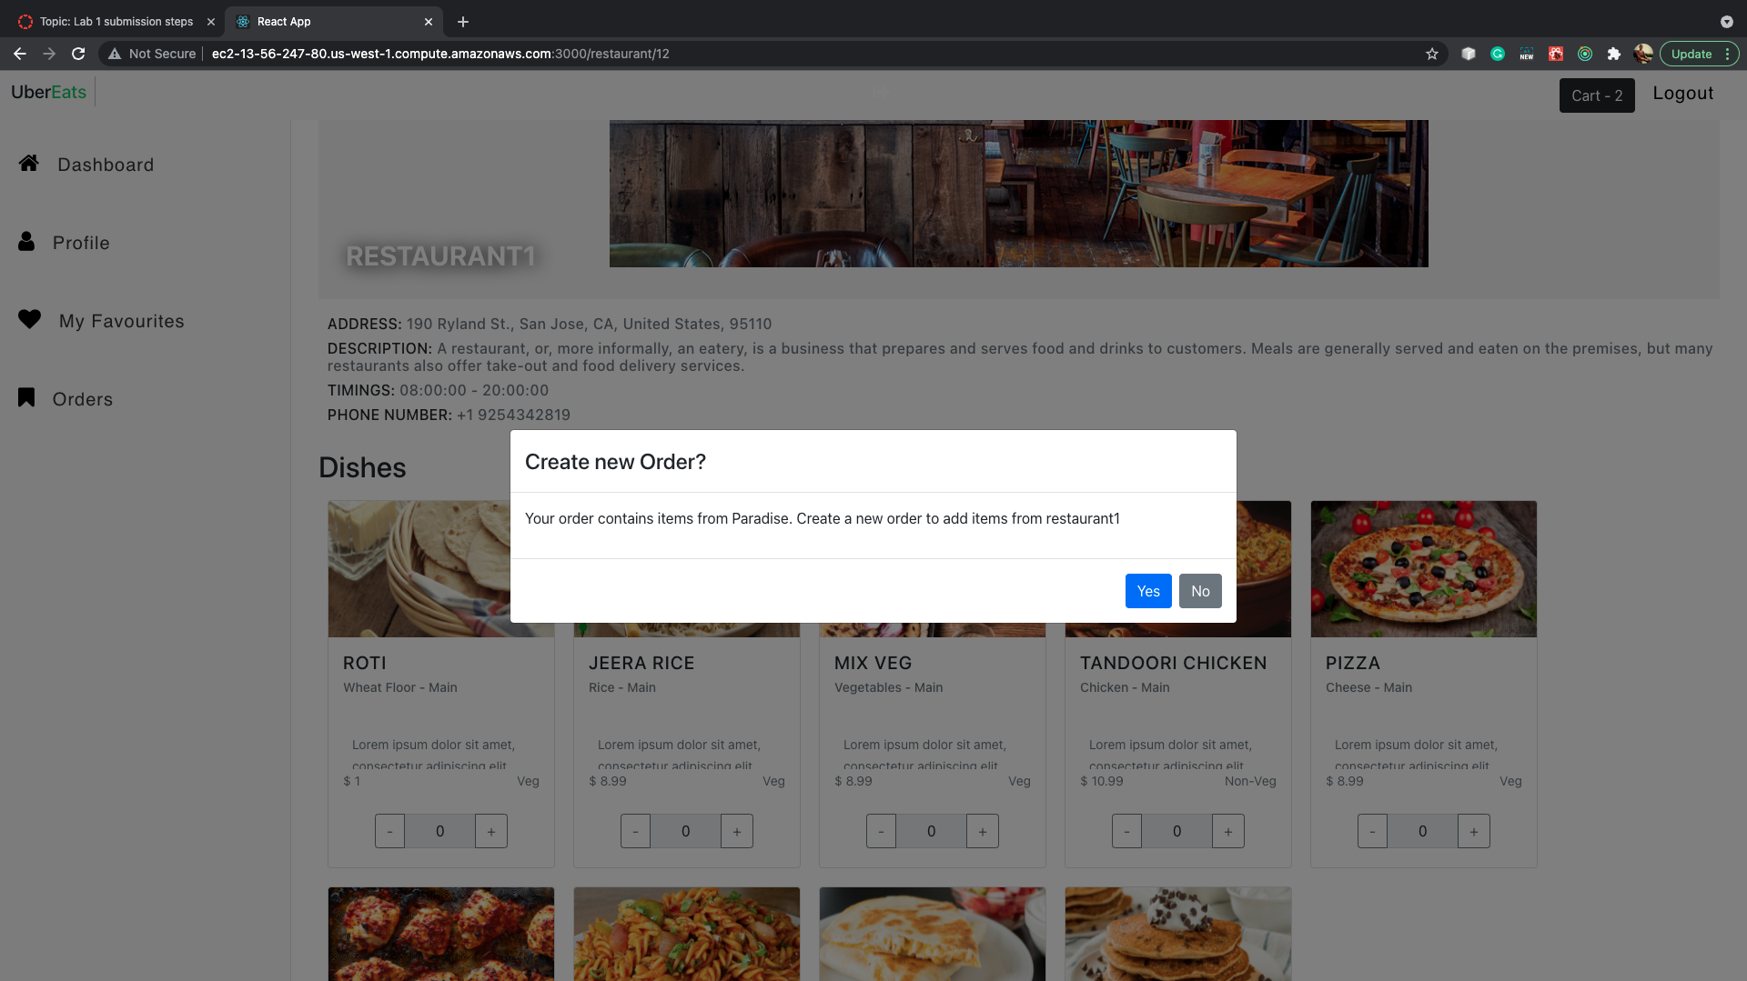

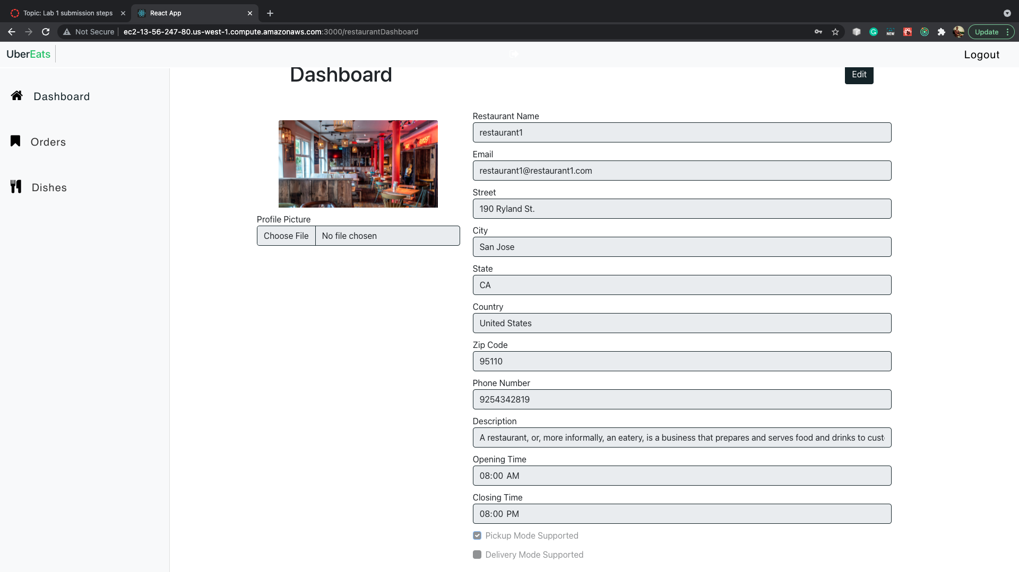

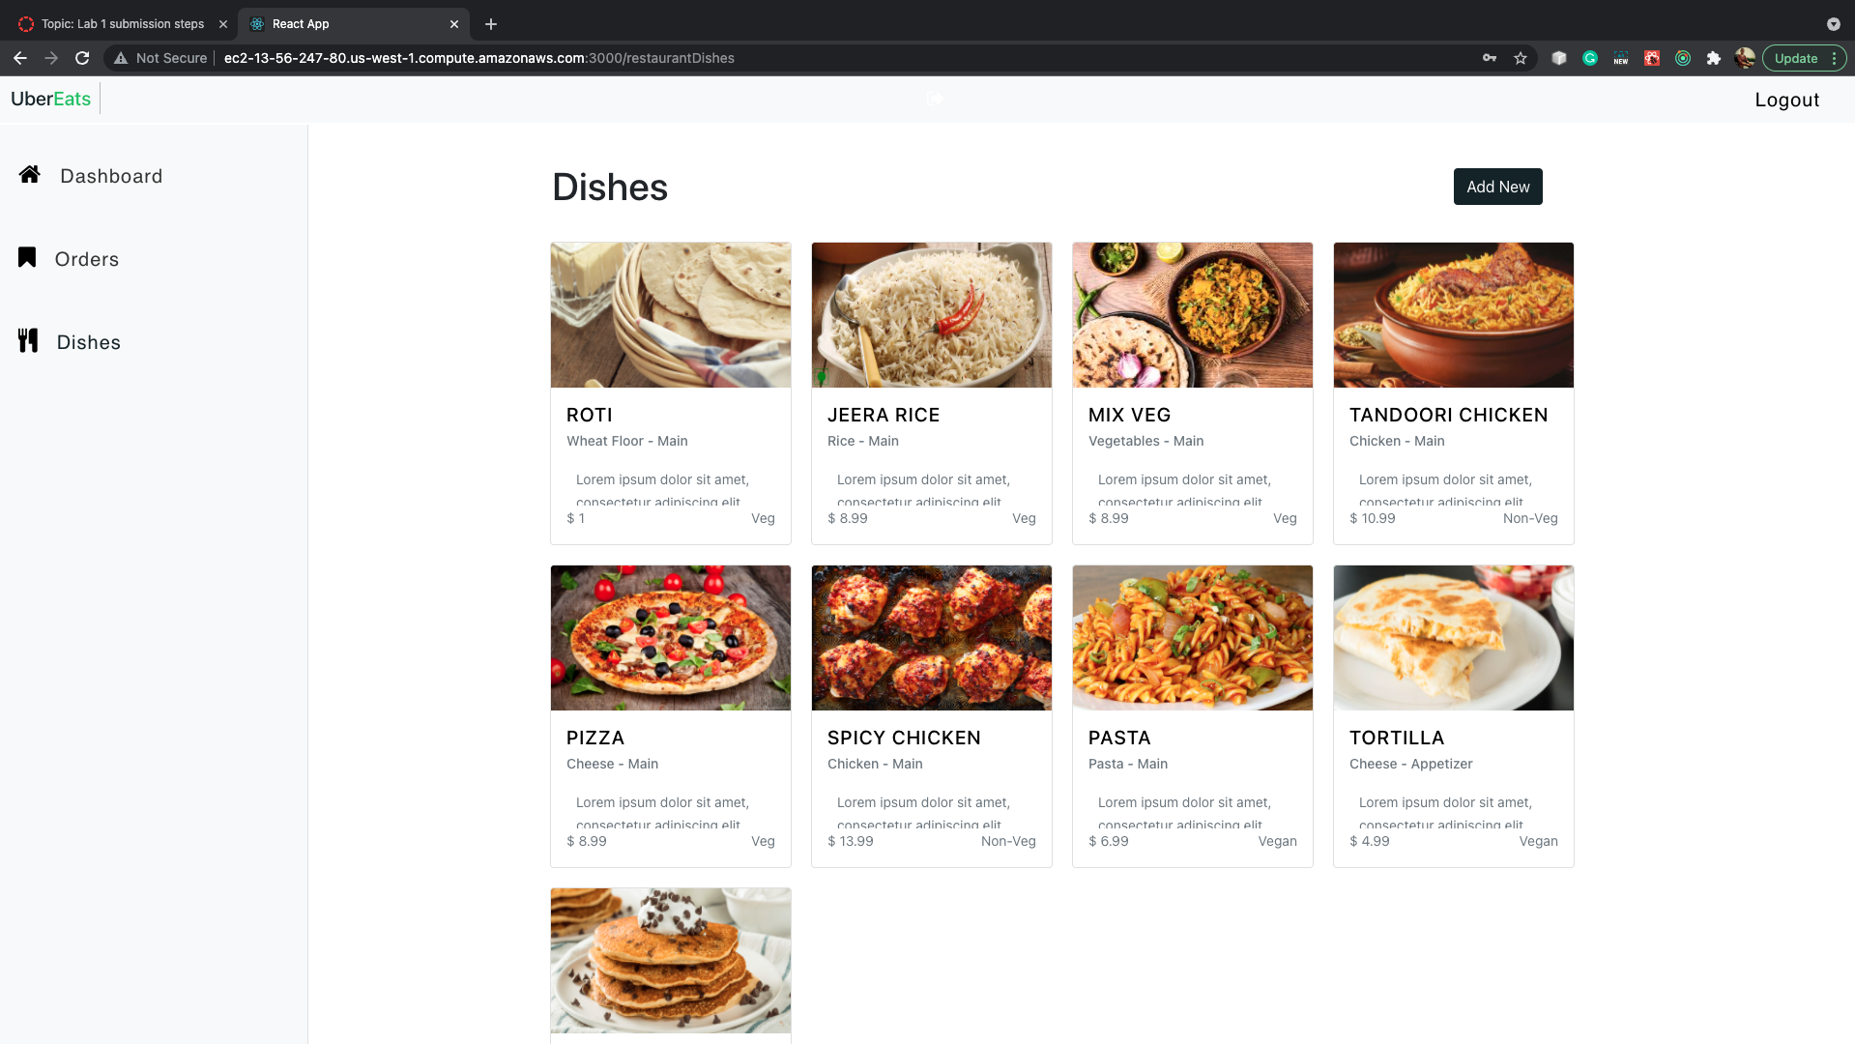

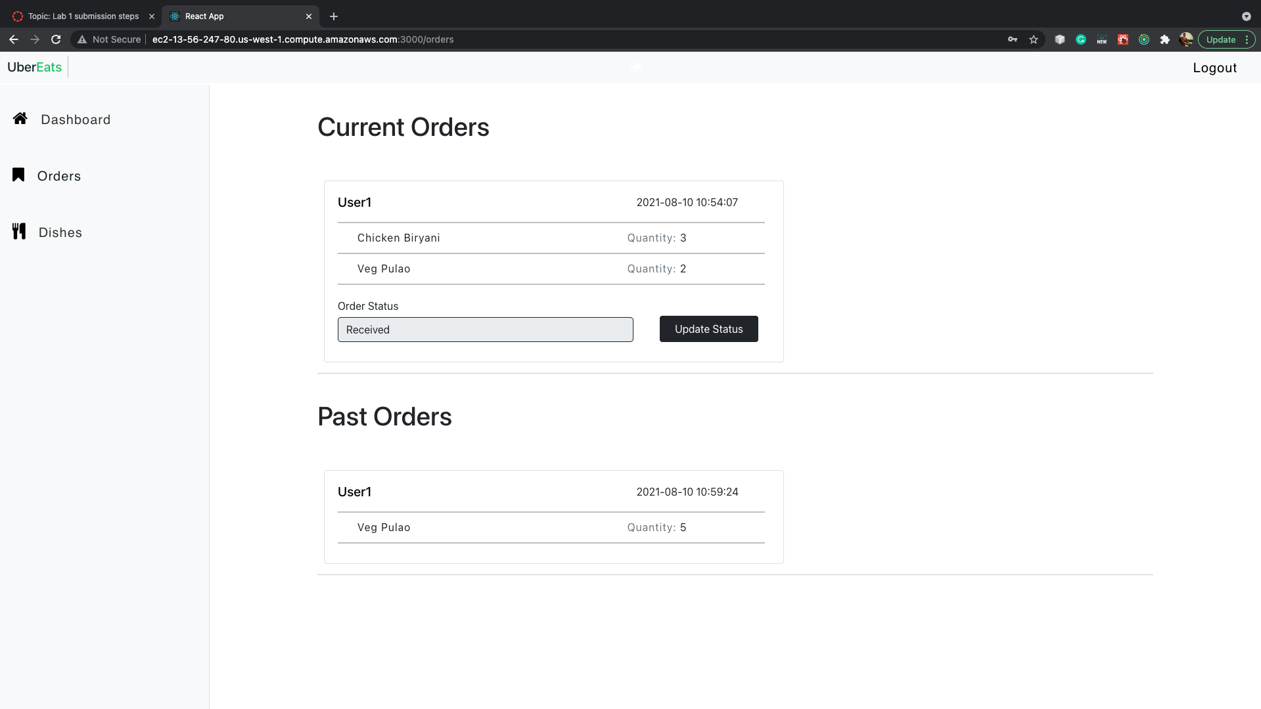

**JMeter Testing:**

The application was tested with JMeter using 100, 200, 300, 400 and 500 threads. The throughput averaged around 6000 per minute with connection pooling and around 3000 without connection pooling.

**With Connection Pooling – (mongodb connection pool - 20)**

**100 –**

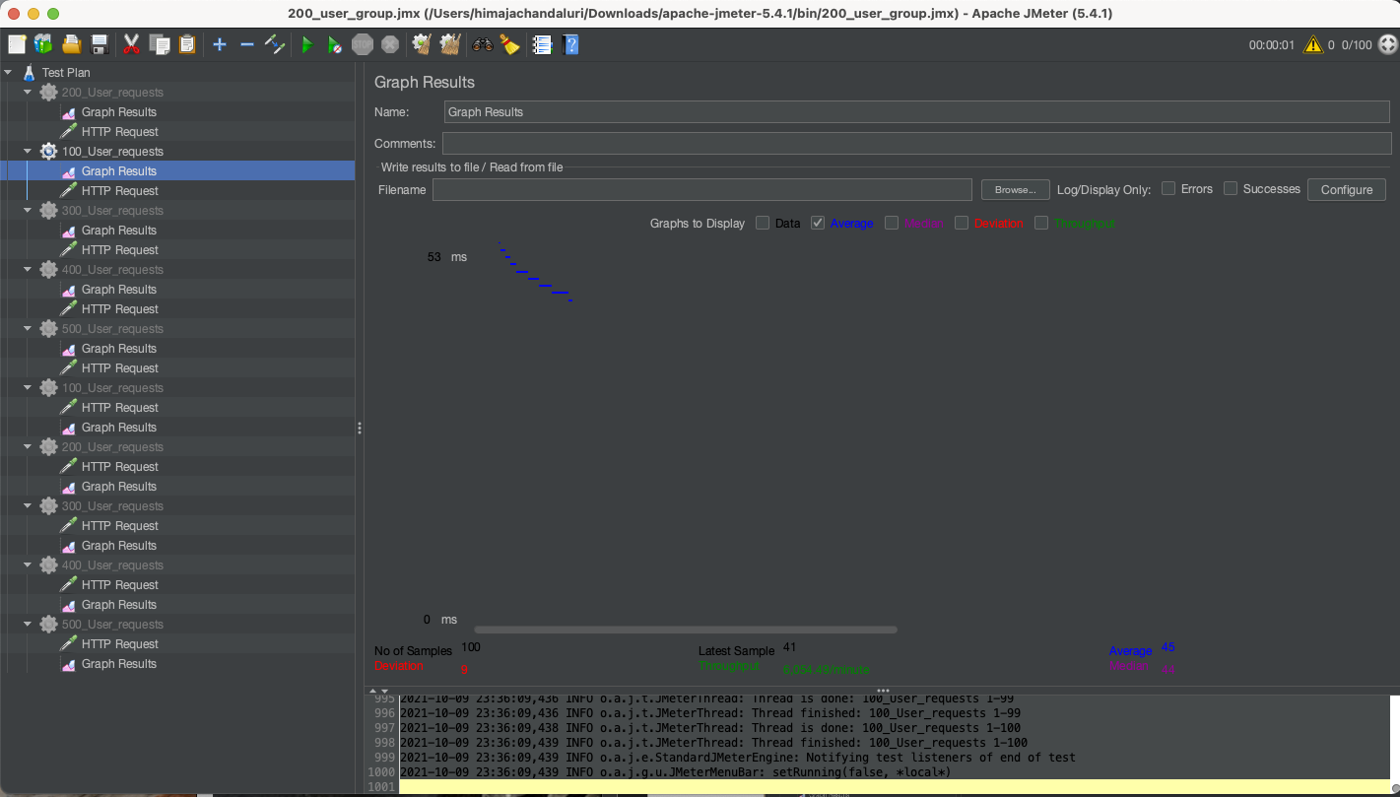

**200 –**

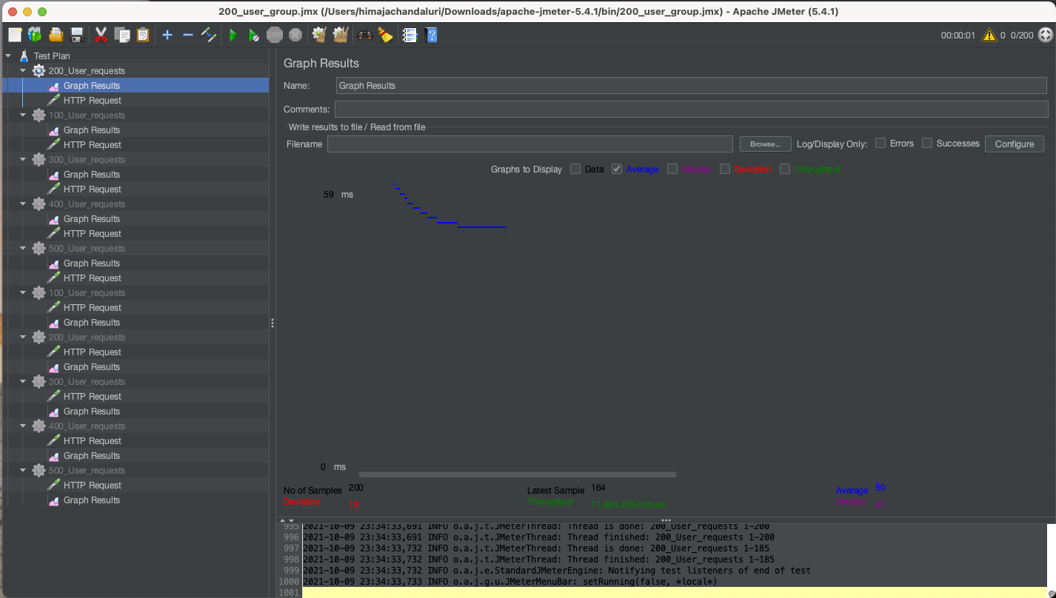

**300 –**

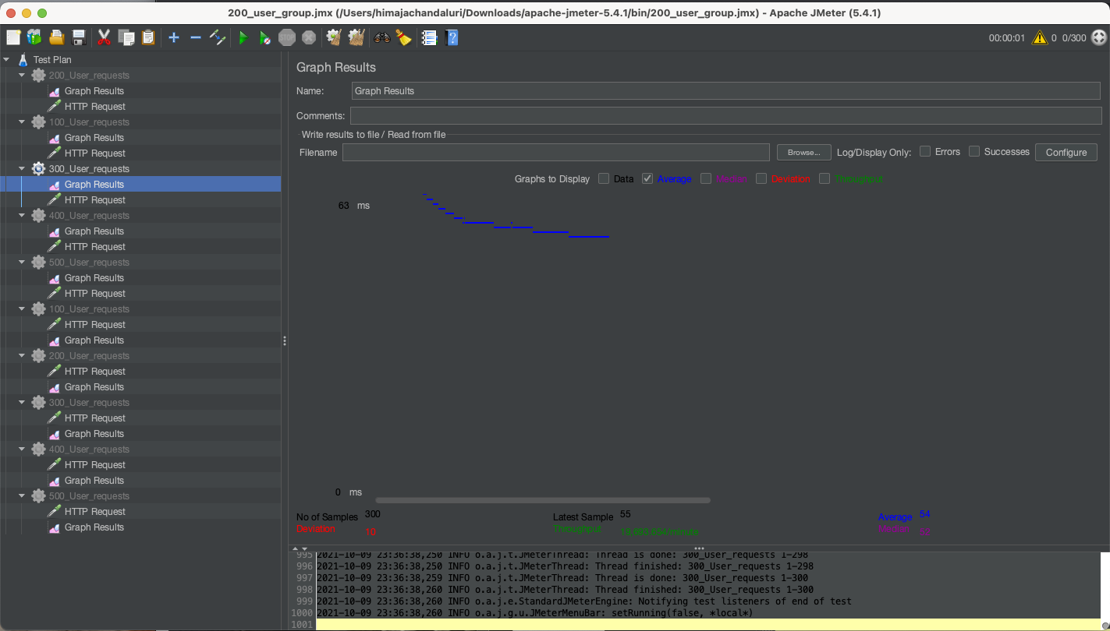

**400 -**

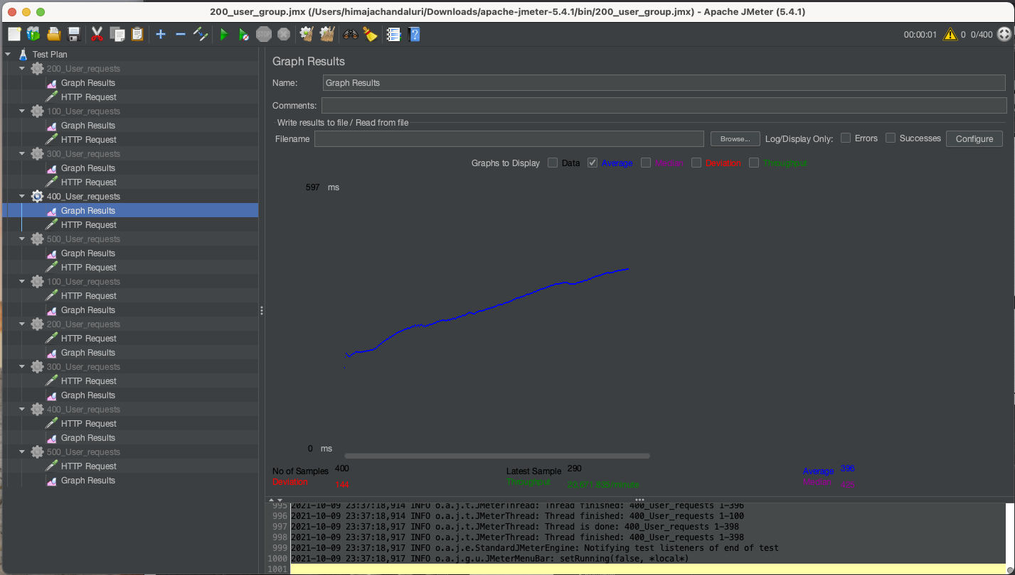

**500 –**

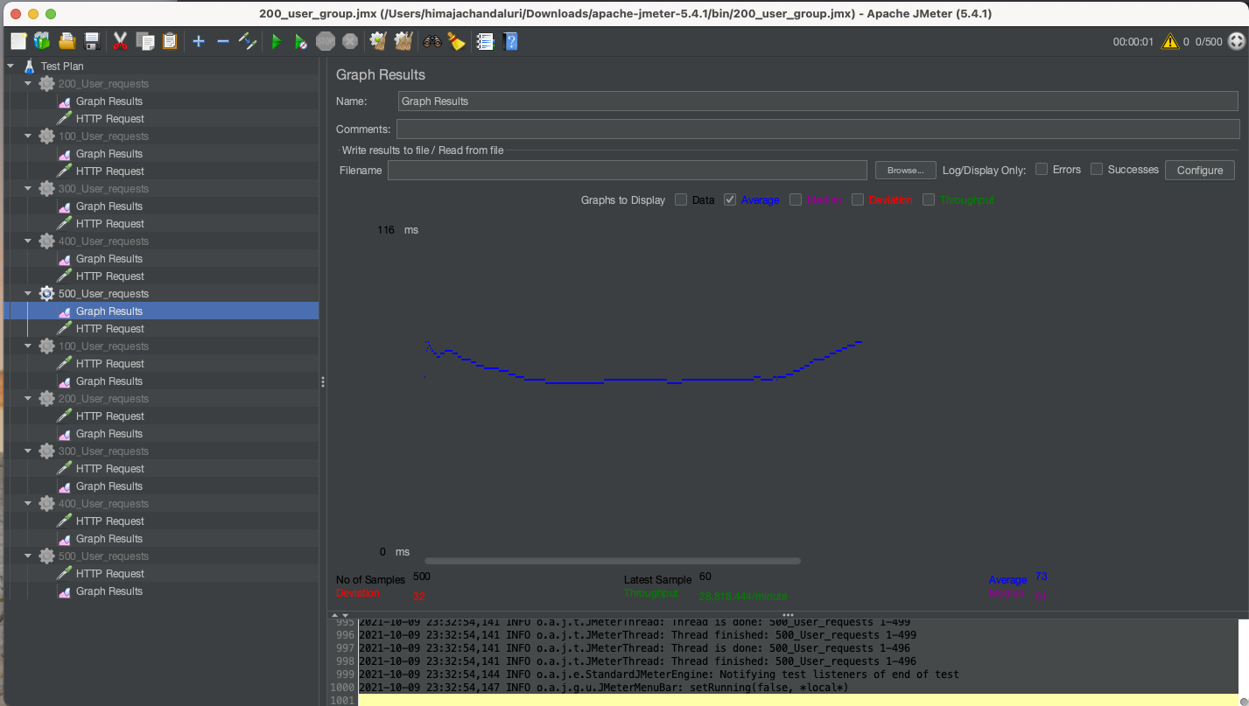

**Without Connection Pooling – (MongoDB connection pool default – 5)**

**100 –**

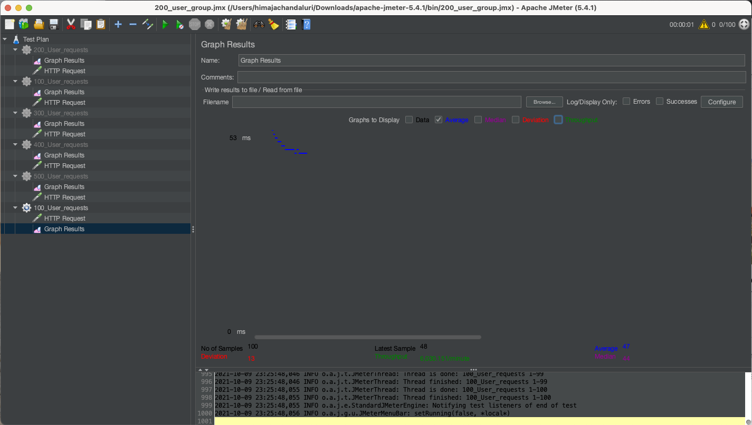

**200 –**

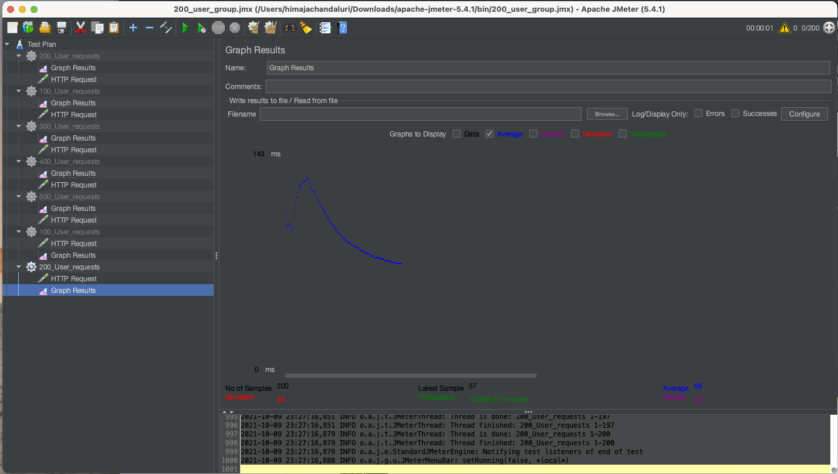

**300 –**

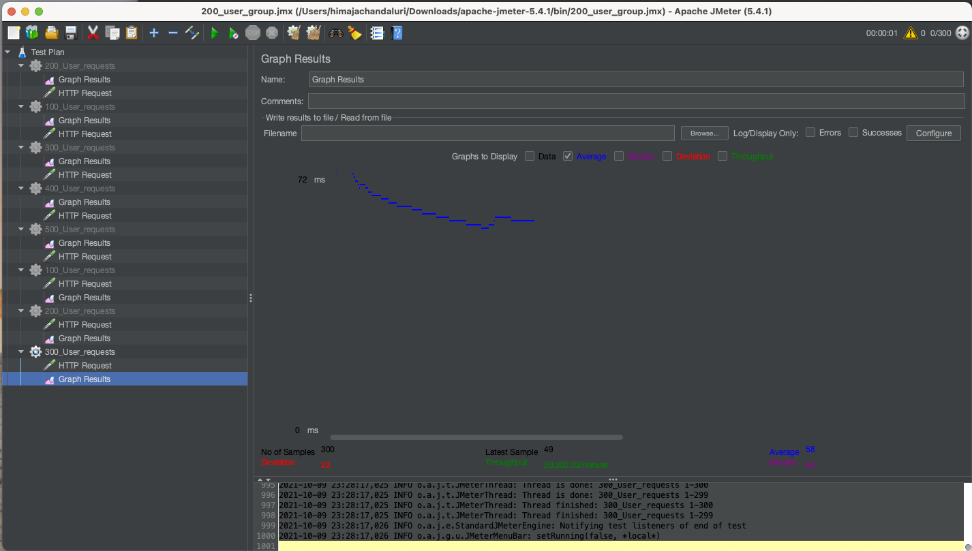

**400 –**

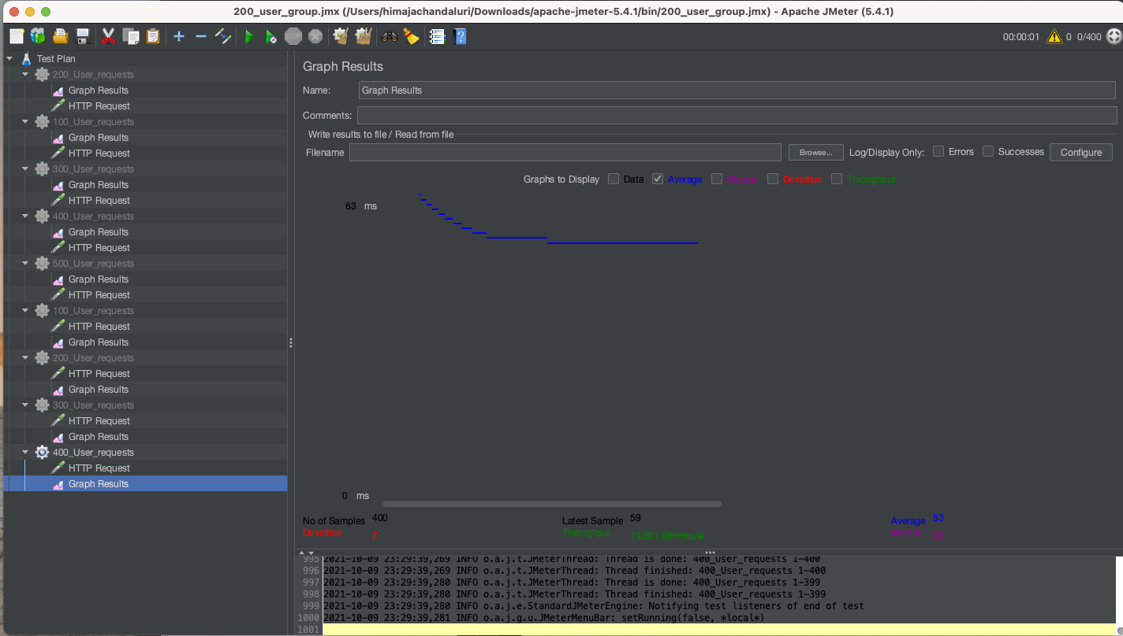

**500 –**

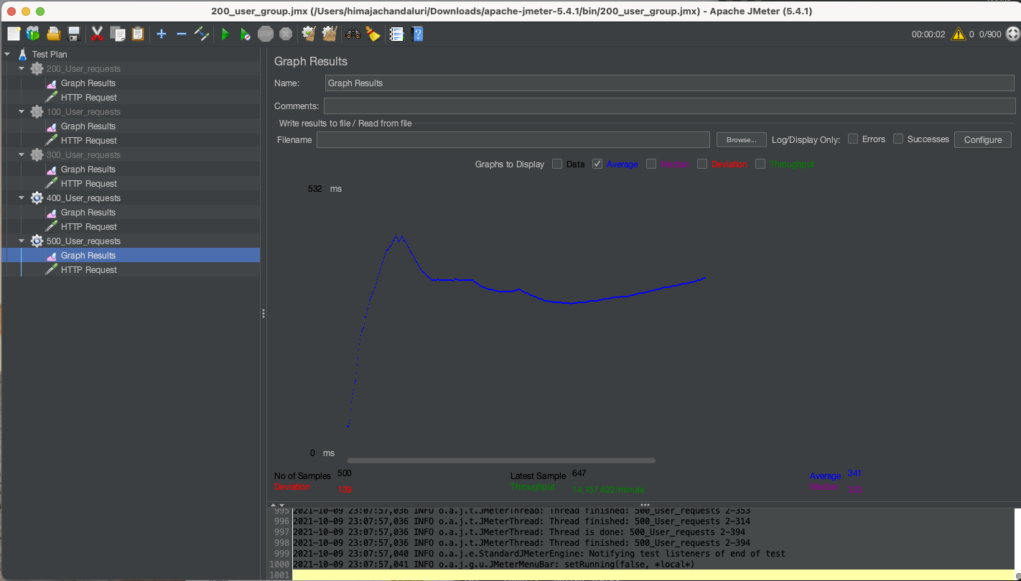

**Mocha Testing**

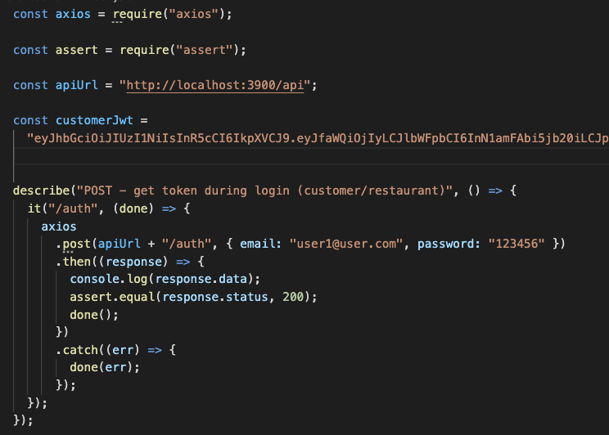

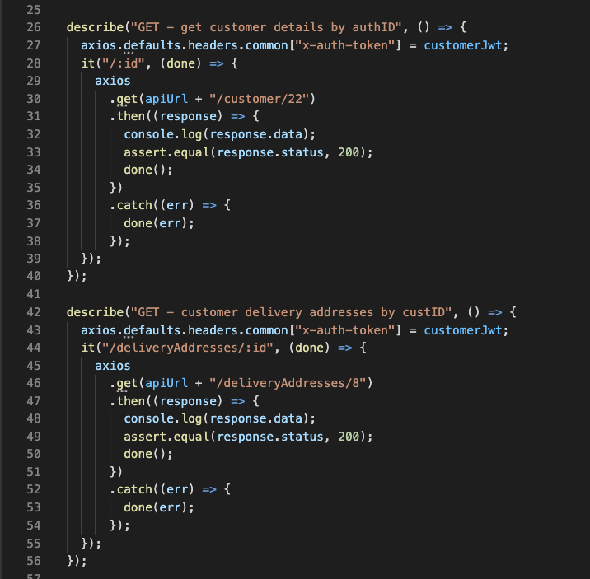

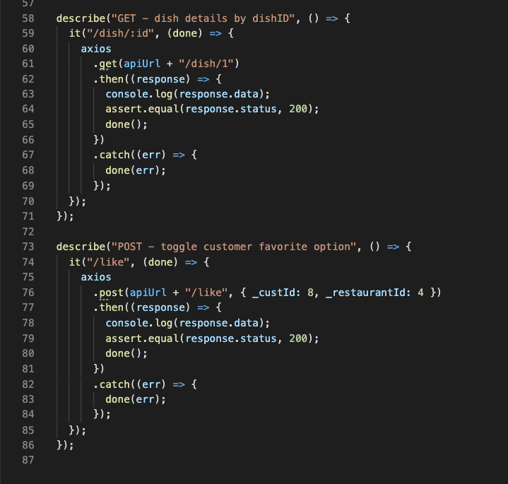

**Output:**

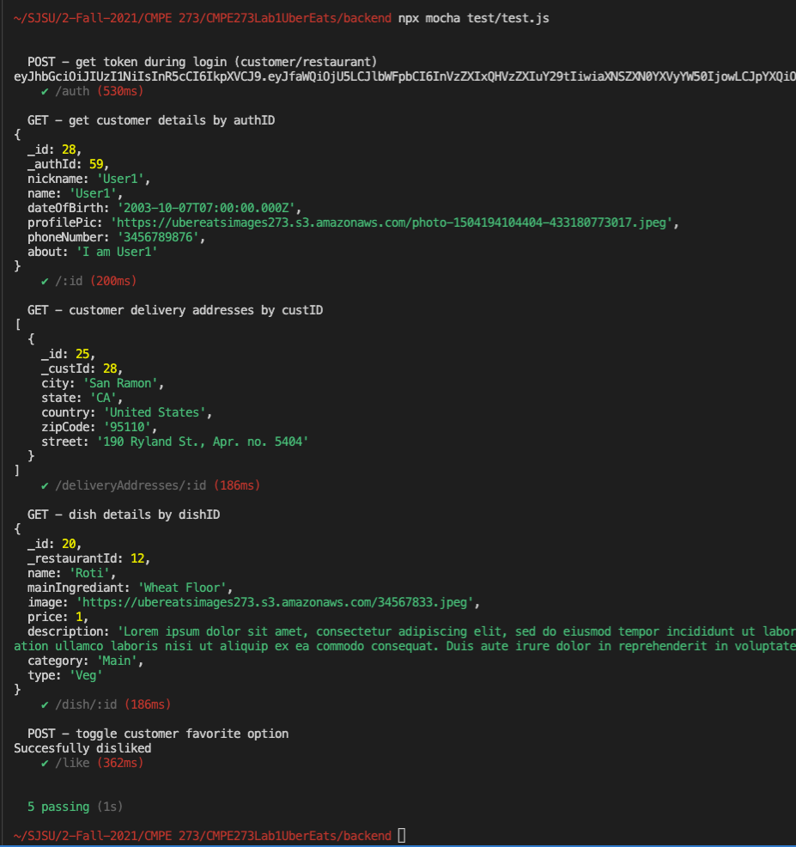

**React Testing:**

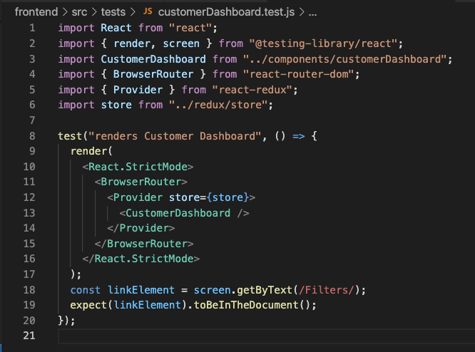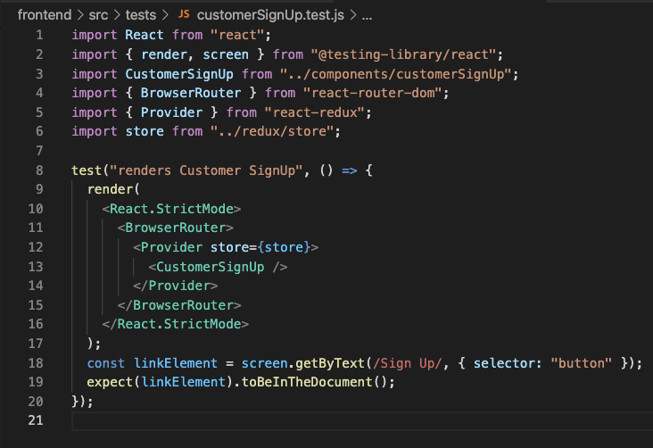

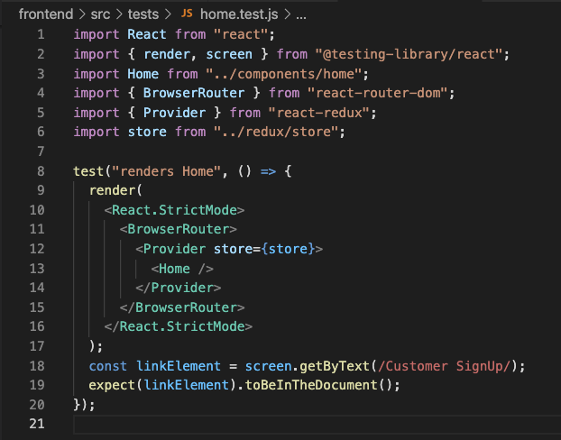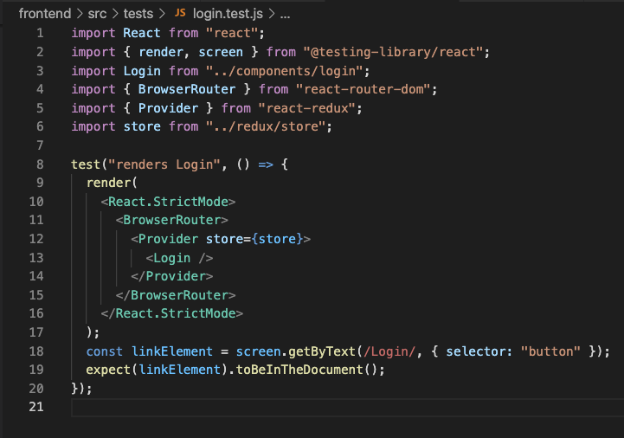

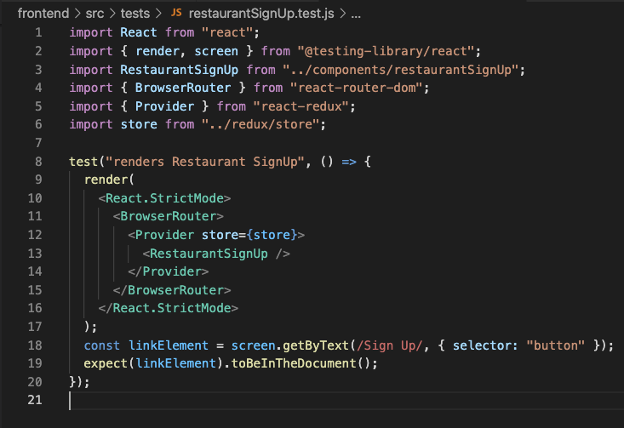

**Output:**

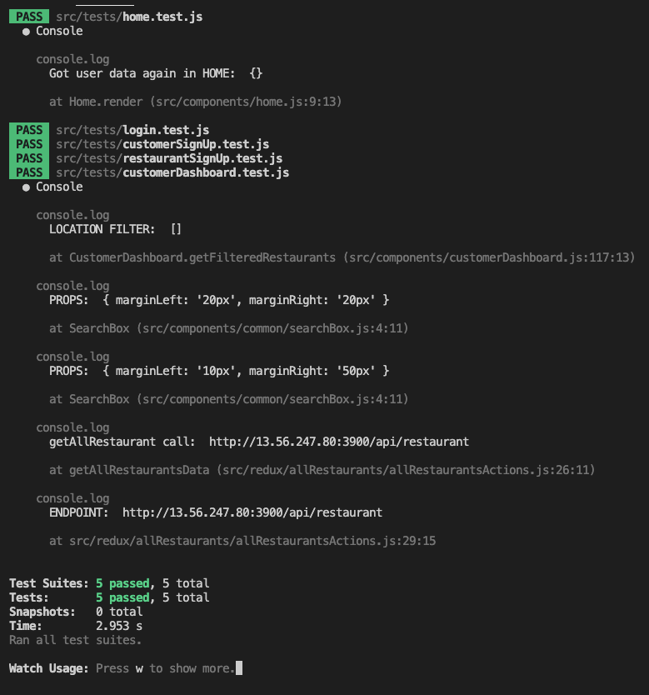

**Git repository:**

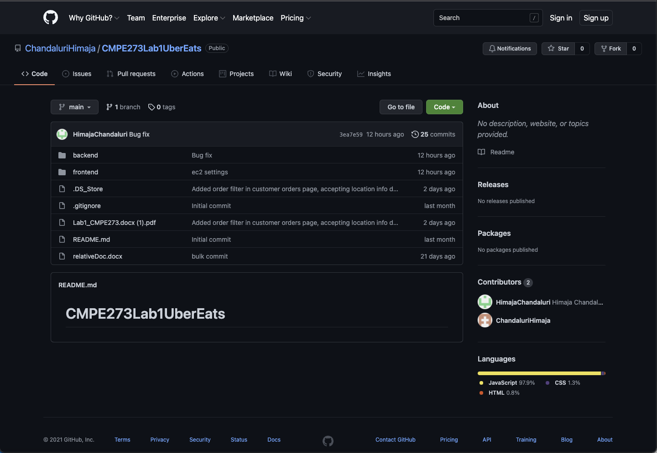

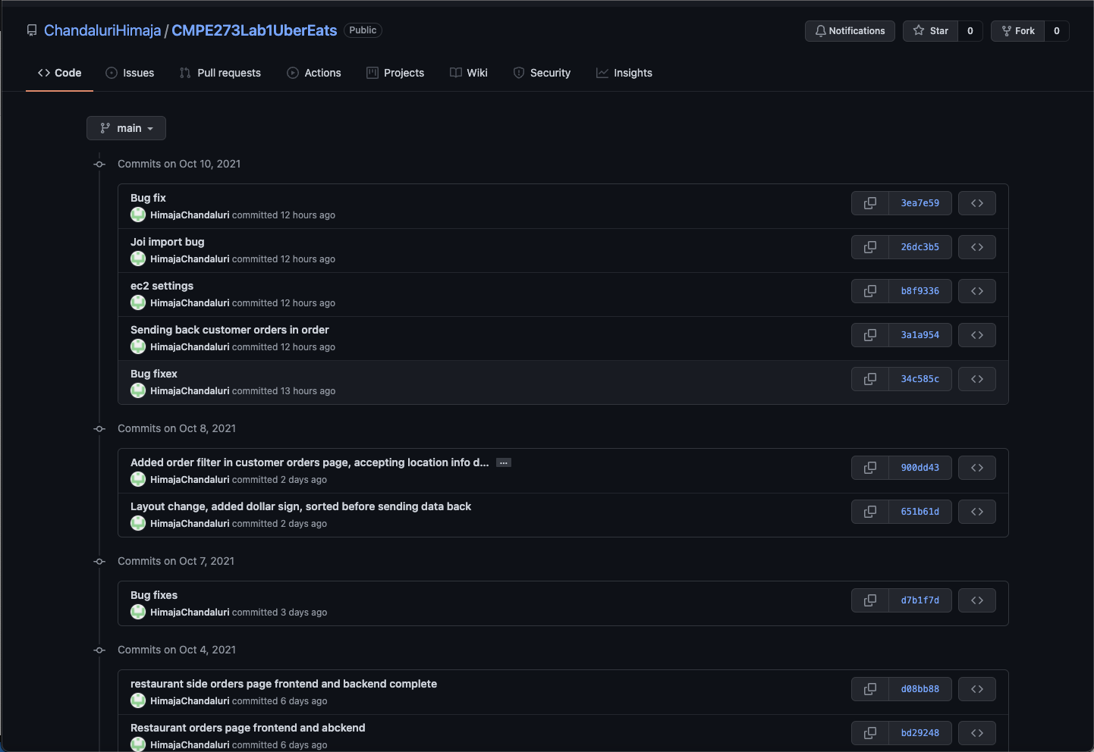

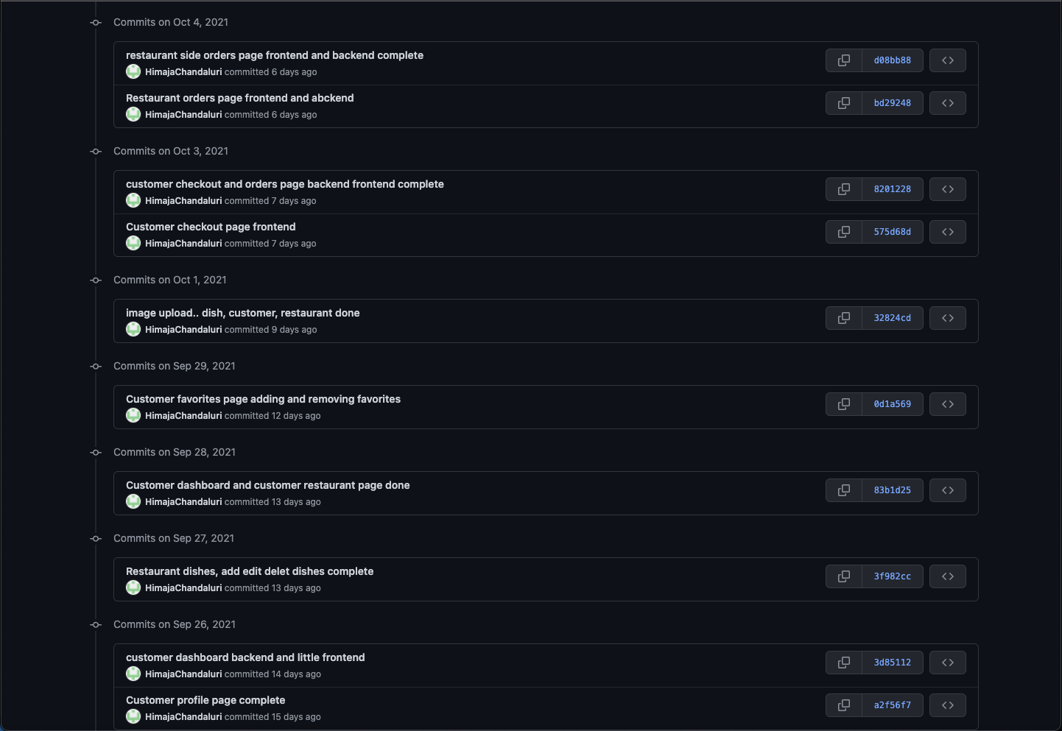

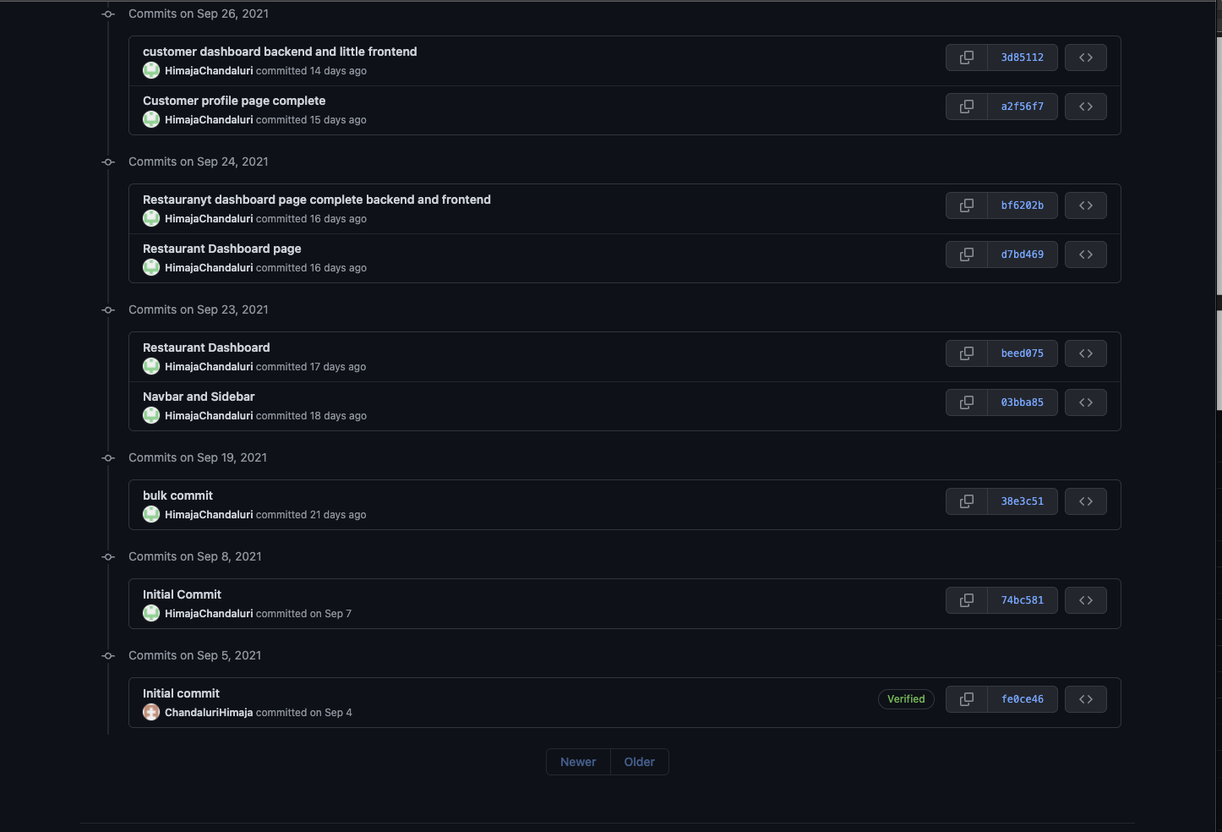

Questions:

1. **Comparison of passport authentication process Vs the authentication process used in Lab1.**

In Lab1 I implemented authentication using JWT tokens by using the jsonwebtoken library directly, without any middleware. In Lab2 I used the Passport-JWT strategy from the Passport middleware.

1. **Performance comparison with and without Kafka**

Kafka makes sure that a request is not lost when the backend is overloaded with requests. It does this by placing a request into a message queue. Whenever the previous request execution is completed a new request from the queue is taken and processed. But Kafka does not increase the performance of the system. With Kafka in place an API call has to travel more in the network to reach the database layer and fetch the data and respond back to the frontend. Thus, using Kafka reduces the performance of the system but increases the latency of the system.

1. **If given an option to implement MySQL and MongoDB both in your application, specify which part of the data of the application you will store in MongoDB and MySQL respectively.**

If given an option I might store User login credentials in MySQL database and the rest of the data in the MongoDB database. Because login credentials are read multiple times but updated rarely MySQL is a good option. The rest of my data has fields with array of values which makes the data schema unstructured. MongoDB being an unstructured database best fits this requirement.